Preface and Project Overview

For the purposes of convenience, I decided to temporarily put the “module-10” directory onto my desktop while I tested the codes. The final deliverable will follow the required file structure for the GitHub submission.
This project demonstrates desktop interface development using Python's native tkinter library. The application transitions from a basic scrollable list implementation into an customized To-Do manager. The program utilizes event-driven programming to handle task addition, dynamic UI updates, mouse click bindings, and window management.
Step 1: Base Application Execution
The initial script (listing_2.2_our_scrolling_to_do.py) establishes the core layout using a tk.Canvas and tk.Frame structure to support dynamic scrolling. The window displays default styling with alternating light and dark gray task items.
Figure 1: Initial Scrolling To-Do App Execution
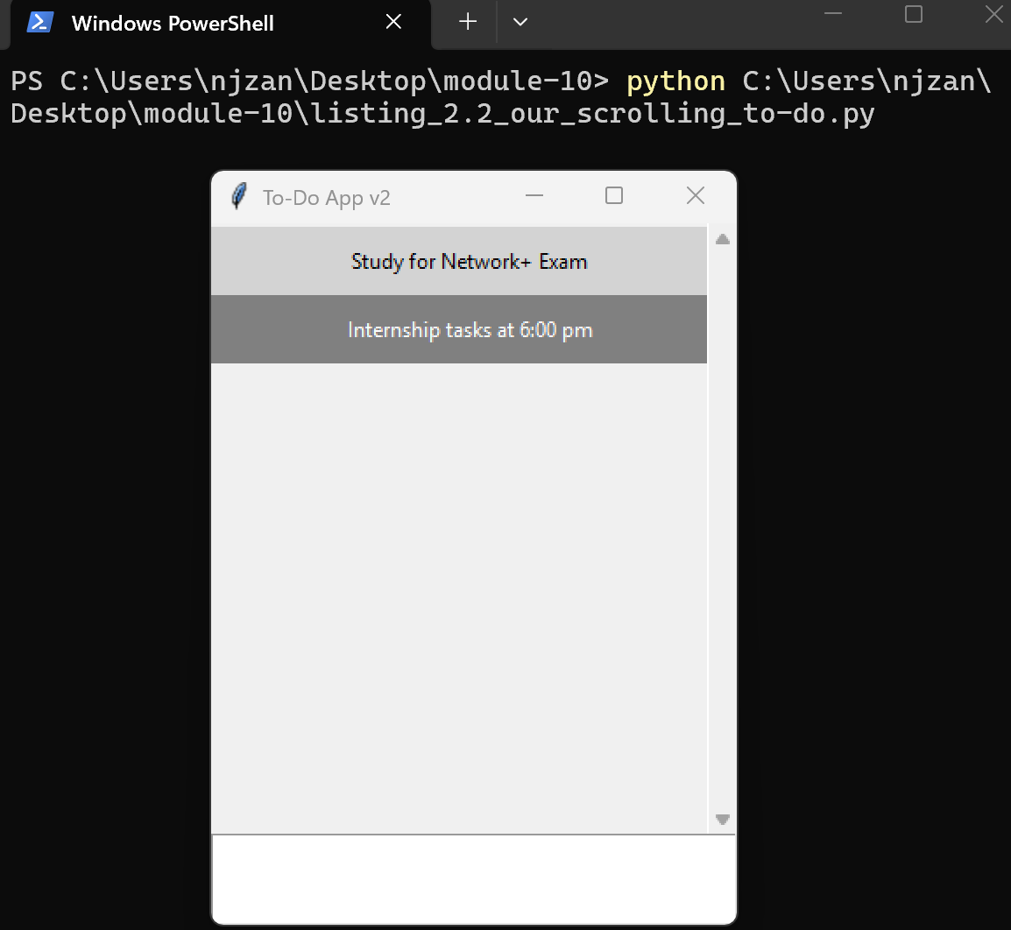
Step 2: Modified Application Implementation
The modified script (zankl_todo.py) incorporates all required GUI enhancements:
- Custom Window Title: Updated to Zankl-ToDo.
- Menu Bar Addition: Added a top-level File menu containing an Exit command to gracefully close the application.
- Instruction Header: Embedded a purple banner (#8A2BE2) instructing users on how to delete tasks using right-click.
- Complementary Styling: Applied alternating gold (#EAB308) and purple list item backgrounds for visual balance.
Figure 2: Modified Application with Active Tasks
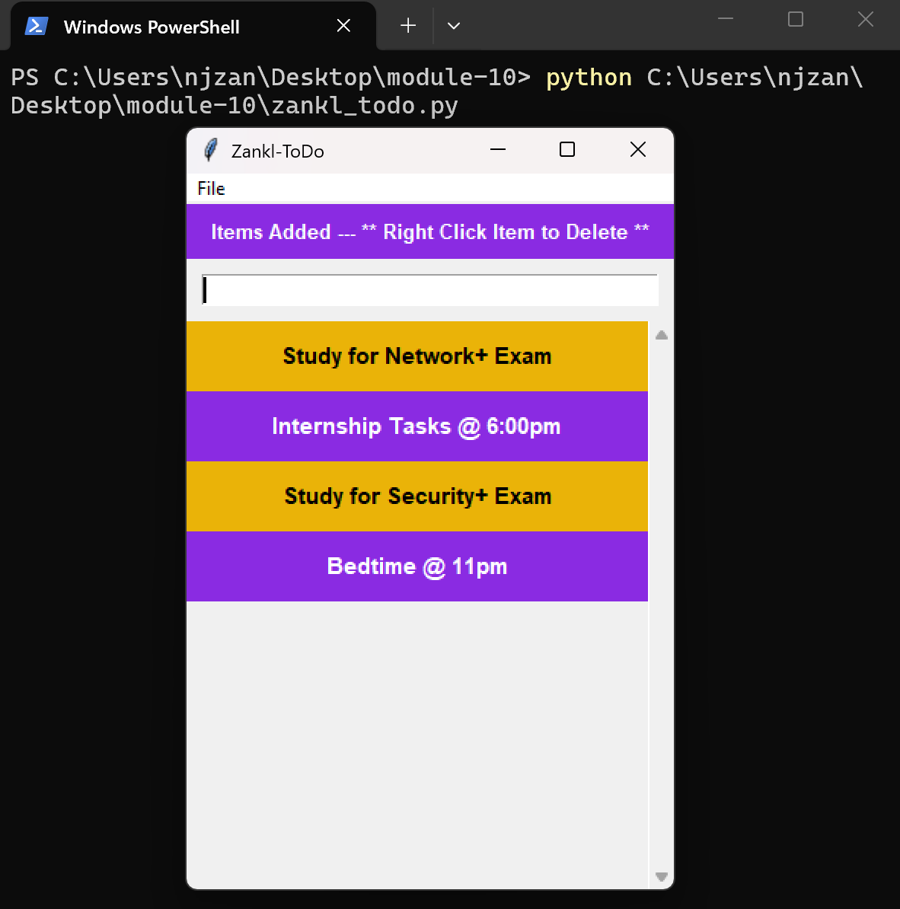
Step 3: Event Binding and Item Deletion
Mouse click events were reconfigured from left-click (<Button-1>) to right-click (<Button-3>). Clicking any task widget directly removes it from the list container and triggers a re-pack layout update.
Figure 3: Task Deletion Action
